Stephanie Freas
LIS 2407
July 22, 2013

Video Game Metadata Standard
Context:
In an effort to encourage more use and cardholders, the Morrowind Public Library has recently acquired a new collection of video games for checkout and playing on the consoles at the library. Nearly 200 games have been received by donations from the community as well as a grant from the local bank. To keep inventory of the games, the library staff has decided to create a metadata schema for the digital collection of the games so that users can view the available games for checkout and play online.
Digital Content: This collection contains a variety of video games, both digital and in hard copies. The digital content consists of images taken of the games to provide the most detailed description possible so that users can get a clear understanding of what the library has available. The focus of the collection is in Roleplaying (RPG) and single-player games for consoles, computers, and portable devices 2005 and later.
Envisioned Users:
Primary—Video game lovers who want to find new games, including hobbyists and young adults in the town of Morrowind
Secondary—People researching contemporary entertainment history
Functional Requirements
Browsing by:
- Alphabetical Title Browse
- Developer
- Publisher
- Category
Searching/Limiting by:
- Title
- Console
- Keyword
Faceted Navigation:
- Rating
- Player Count
- Format
All elements that are repeated must be separated by each field.
Refrain from using any abbreviations and utilize Local Authority Files when available.

Metadata Application Profile
Element  Name | DC Mapping | MODS Mapping | Controlled Vocabulary | Obligation | Cardinality | Input Guidelines | Examples
Title | Title | <TitleInfo><title> |  | Required | Yes | Name of title given by publisher. If none given, supply an appropriate one. | - Resonance of Fate  - XCOM  - Ni no Kuni  - Fallout 3
Subtitle | Title | <TitleInfo><title> |  | Required if Available | Yes | If a title is separated by a colon or has a subtitle separated from larger work, input subtitle(s) here. | - New Vegas  - Enemy Unknown  - Among Thieves  - Wrath of the White Witch
Developer | Creator | <name><namePart> <role><roleTerm type=”text”> | LCNAF-Corporate | Required if Available | No | Use Corporate version of LCNAF for developers. | - Naughty Dog, Inc.  - BioWare Corp.  - Fiaraxis  - Sega of America (Firm)  - Rockstar Games (Firm)
Publisher | Contributor | <name><namePart> | LCNAF | Required if Available | No | Use Corporate version of LCNAF for publishers. | - Sony Computer Entertainment  - Nintendo of America, Inc.  - Atlas  - Square Enix (Firm)  - Electronic Arts (Firm)
Additional  Content | Relation | <relatedItem> |  | Required if Available | Yes | Two options for AC:  DLC (Downloadable Content) or EP (Expansion Packs). When entering AC, identify either DLC or EP. | - EP: Burning Crusade  - EP: Wrath of the Litch King  - EP: Cataclysm  - DLC: The Stone Prisoner  - DLC: Warden’s Keep  - DLC: Mothership Zeta  - DLC: The Pitt
Console | Format | <physicalDescription><extent> | Local Authority File—See examples | Required | Yes | Only enter the console information of the game that is owned, not the information about what consoles the game may be played on. | - Xbox  - Xbox 360  - PC  - Playstation 2  - Playstation 3  - RDP  - Gameboy Color  - Nintendo DS  - Nintendo Wii
Description | Description | <abstract> |  | Required if Available | Yes | Provide a brief (1-4 sentences) description of the game that isn’t highlighted in other fields. This may include a small synopsis of the gameplay. | - Users will play as Roman, a European immigrant, who seeks to find fortune with his cousin in the fictional Liberty City. The duo find trouble in a criminal underworld while completing quests.  - In this expansive collection of forty original Sega Genesis games, users can play individually or with others to unlock content and experience new adventures.
Date | Date | <originInfo><dateIssued> | W3CDTF | Required if Available | Yes | Give the full published date, including month, day, and year, if available. | - 2012  - 2010-02-19  - 2000-2002  - 2001?  - 1998-07
Rating | Description | <TargetAudience> | Local Authority File-based on ESRB ratings | Required if Available | No | Use the ESRB Ratings for video games, as shown on the game cases. If no rating is given, leave blank.  http://www.esrb.org/ratings/ratings_guide.jsp | - eC  - E  - E+10  - T  - M  - Ao  - RP
Format | Format | <format> | Local Authority File-see examples | Required if Available | No | Identify the format that the game comes on, either in hard copy or as a digital download. | - Blu-ray  - DVD-Rom  - Digital Download  - UMD
Subject | Subject | <subject> | LCSH | Required if Available. | Yes | Use terms from the Library of Congress Subject Headings, as needed. If no terms are available, mimic the LCSH style.  Many Subject Headings will end in Computer Games  or Video Games. | - Survival--Video Games  - Fortune hunters--Computer Games  - Dystopias—Video Games  - Space Warfare—Computer Games
Player  Count | Description | <note> | Local Authority File—see examples | Required | No | Provide the number of players that can simultaneously play the game. | - Player 1  - Players 1-4  - Players 2-5  - Network Players 2
Requirements | Description | <note> |  | Required if Available | Yes | Identify any requirements the game needs, such as Internet connection, memory space on the console, subscription | - Internet Connection  - Xbox Live  - Subscription  - 5 MB to save game
Series | Source | <relatedItem> |  | Required if Available | Yes | Identify if the game is part of a larger series of games. | - The Elder Scrolls  - Final Fantasy  - Mass Effect  - Uncharted  - Fallout
Peripherals | Relation | <relatedItem> |  | No | Yes | Note any peripherals/game acessories that the game uses and separate each peripheral by repeating the field. | - Chatpad  - Headset  - Playstation Move  - Nintendo Wii Motion Plus  - Xbox Kinect
Language | Language | <language><languageTerm type= “text”> | ISO 639-2 | Required if Available | Yes | Identify the languages available in gameplay. | - Eng  - Fra  - Spa  - Ger  - Tah
Identifier | Identifier | <Identifier> |  | Required if Available | Yes | Include any type of identifier for the game. The most notable identifier will be the ASIN number or OCLC number | - B004EQCCI4  - B000FQ2D5E  - B008CP6MA2  - B008CP6Q6M  - 777945497
Category | Description | <note> | Local Authority File (see examples) | Required if Available | Yes | Note what type of game category this falls into, avoiding any abbreviations | - Platforming  - Action  - Roleplaying  - Massive Multiplayer Online  - Beat ‘Em Up  - Open World

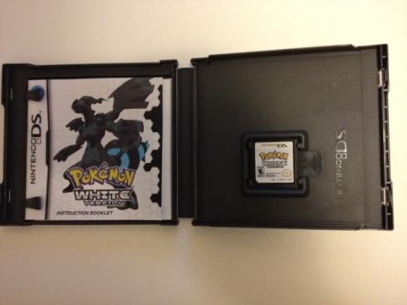
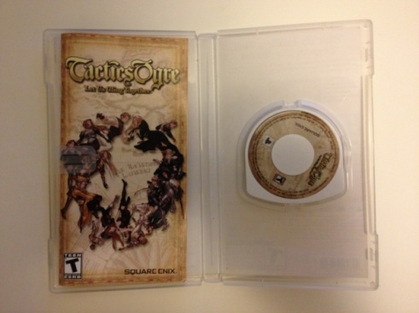

Example Records

- 2.
Title | Tactics Ogre
Subtitle | Let Us Cling Together
Developer | Square Enix (Firm)
Publisher | Square Enix (Firm)
Additional Content
Console | PSP: Playstation Portable
Description | In this tale of political intrigue, users help decide who will rule the land of Valeria.
Date | 2011-02-15
Rating | T
Format | UMD
Subject | Tactics Ogre (Game)
Subject | Fantasy Games-- Computer Games
Subject | Japan--Video Games
Player Count | Player 1
Requirements | 224 KB to save game on SD card.
Series
Peripherals
Language | Eng
Identifier | B003YVK5T8
Category | Strategy Roleplaying
Title | Pokémon
Subtitle | White Version
Developer | Game Freak (Firm)
Publisher | Nintendo of America, Inc.
Additional Content
Console | Nintendo DS
Description | Users will travel the new Unova region and battle Team Plasma to discover the identity of the mysterious N. They can find and battle all new Pokémon in this vibrant adventure.
Date | 2011-03-06
Rating | E
Format | Nintendo game card
Subject | Pokémon (Fictitious characters)—Computer Games
Player Count | Players 2-5
Requirements
Series | Pokémon
Peripherals
Language | Eng
Identifier | B004EVWYG
Category | Roleplaying

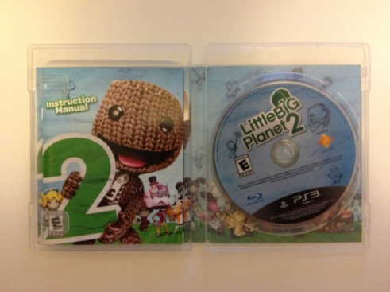

3. 4.
Title | The Sims 3
Subtitle
Developer | The Sims Studio
Publisher | Electronic Arts (Firm)
Additional Content
Console | Xbox 360, PC, iOS
Description | Users can create new characters, make them part of a family, and give them jobs and homes to become a part of the Sim world.
Date | 2009-06-02
Rating | T
Format | DVD-ROM
Format | Download
Subject
Player Count | Player 1
Requirements | 35 MB to save game
Requirements | Digital Download: Internet  connection
Xbox 360: Xbox Live for
multiplayer
Series | The Sims
Peripherals | Xbox 360: Chatpad
Language | Eng
Identifier | B004D1FBZQ
Category | Simulation
Title | Little Big Planet 2
Subtitle
Developer | Media Molecule
Publisher | Sony Computer Entertainment
Additional Content
Console | Playstation 3
Description | Users discover limitless gameplay as they join Sackboy in a whimsical adventure filled with new  characters, clever gadgets, and exciting new game genres to play.
Date | 2011-01-18
Rating | E
Format | Blu-ray
Subject | Computer Adventure--Games
Subject | Adventure and Adventurers--  Juvenile Software
Player Count | Players 1-4
Requirements | Harddrive space: 1430 MB
Series | Little Big Planet
Peripherals | Headset, Playstation Move
Language | Eng
Identifier | B002I0K780
Category | Puzzle, Platforming

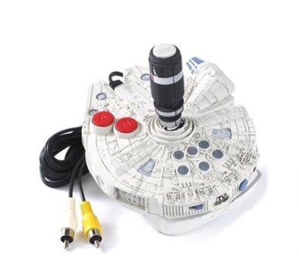
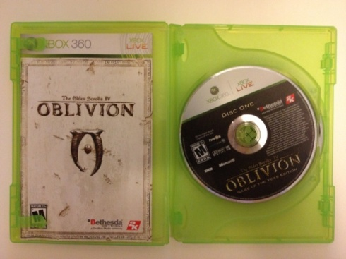

5. 6.
Title | The Elder Scrolls IV
Subtitle | Oblivion
Developer | Bethesda Softworks (Firm)
Publisher | 2K Games
Additional Content | Knights of the Nine
Additional Content | Shivering Isles
Console | Xbox 360
Description | In this action-based fantasy  Game of the Year Edition,  users create a unique character and embark on an exciting quest to close the gates of Oblivion that  have cropped up in the land of Cyrodil.
Date | 2011-09-27
Rating | M
Format | DVD-ROM
Subject | Fantasy--Computer Games
Subject | Adventure and Adventurers—  Computer Games
Player Count | Player 1
Requirements | 1146 MB to play
Series | The Elder Scrolls
Peripherals
Language | Eng
Identifier | B005FDUSTA
Category | Action Roleplaying
Title | Star Wars 5-in-1 Plug N Play TV Game
Subtitle | Millennium Falcon
Developer | Jakks Pacific
Publisher
Additional Content
Console | Plug N Play TV Game
Description | With the Millennium Falcon as the controller, users can play five different complete games based in the Star Wars universe.
Date | 2006
Rating | E
Format | Plug-N-Play Arcade Joystick
Subject | Star Wars--Video Games
Subject | Action and Adventure--  Video Games
Player Count | Player 1
Requirements | 4 AA batteries
Series | Star Wars Plug-N-Play TV Games
Peripherals
Language | Eng
Identifier | B00074FYBY
Category | Action

